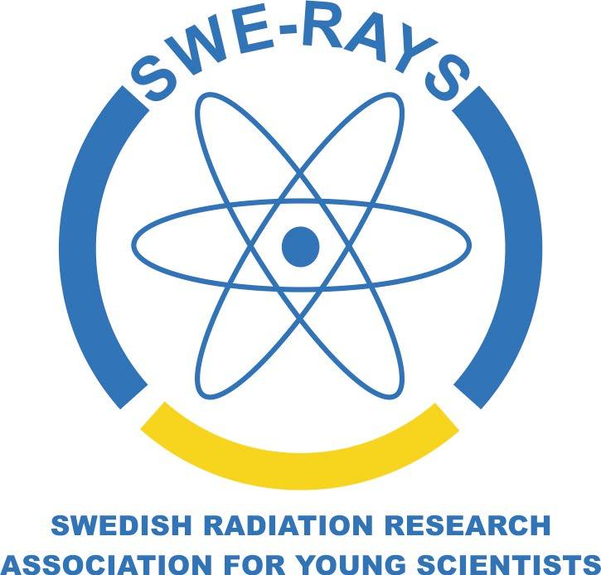

Workshop 2022
Stockholm University,
23rd – 25th of August 2022
Schedule
Tuesday 23rd August | Moderator: Mikael Elvborn
13.00-13.45 | Registration, putting up posters, uploading presentations and fika
13.45-14.00 | Introduction to SWE-RAYS workshop
14.00-14.30 | Invited speaker: Andrzej Wojcik (Stockholm University), “Facts and values in radiation protection research”
14.30-14.50 | Oral presentation, Zuzana Kocibalova (Stockholm University), “Adverse outcome pathways involved in radiotherapy-induced second cancers of childhood cancer survivor”.
14.50-15.00 | Short break
15.00-15.20 | Workshop activity: “Elevator pitch” (Mikael Elvborn and Martin Hjellström)
15.20- 16.00 | Posters/End of session.
19.00 | Welcome dinner (Restaurang Mårten Trotzig)
Wednesday 24th August | Moderator: Martin Hjellström
08.45-08.55 | Coffee
08.55-09.00 | Introduction
09.00-09.30 | Invited speaker: Per Seltborg/Christian Linde (SSM), talk on SSM and the national competence strategy
09.30-09.50 | Oral presentation, Tabassom Mohajer Shojai (Uppsala University), “Potential combination therapy with ¹⁷⁷Lu-DOTA-M5A anti-carcinoembryonic antigen humanized antibody and HSP90 inhibition for colorectal cancer”.
09.50-10.10 | Oral presentation, Nishte Rassol (Sahlgrenska Academy at University of Gothenburg), “Transcriptional effect on apoptosis and oxidative stress in NET GOT1 tumor during coadministration of ¹⁷⁷Lu-octreotate and radical scavenger A1M”.
10.10-10.40 | Posters and Fika
10.40-11.00 | Oral presentation, Frida Westerbergh (Sahlgrenska Academy at University of Gothenburg), “Patient-specific kidney recovery coefficients may increase dosimetric accuracy for ¹⁷⁷Lu-radiopharmaceutical treatment”.
11.00-11.30 | Invited speaker: Mats Eriksson (SSM), talk on scientific experience and career paths.
11.30-11.45 | Discussion
11.45-12.00 | Walk to lunch restaurant (Lantis, SU campus)
12.00-13.00 | LUNCH
13.00-14.50 | Workshop activity (Mikael Elvborn and Martin Hjellström)
14.50-15.20 | Posters and Fika
15:20-15:35 | Words from our sponsor: Hadis Westin (RIDGEVIEW INSTRUMENTS AB)
15.35-15.55 | Oral presentation, Jonathan Tranel (University of California San Francisco), “Deposited energy microdistribution of ¹⁷⁷Lu and ²²⁵Ac in a model of cancer associated fibroblasts”.
15.55-16.00 | End of session
Thursday 25th August | Moderator: Milagrosa Lopez
08.45-08-55 | Coffee
08.55-09.00 | Introduction
09.00-09.10 | Invited speaker: Lovisa Lundholm (SAINT), presentation about SAINT
09.10-09.30 | Oral presentation, Jonathan Sundström (University of Gothenburg), “Models for estimating radiation dose and LAR from radioactive fallout: extended dose algorithms for the computational tool LARCalc”.
09.30-09.50 | Oral presentation, Milagrosa López-Riego (Stockholm University), “Inter- and intraindividual response to alphas, X-rays and mixed beams analysed at exon-level gene expression and chromosomal aberrations”.
09.50-10.15 | Posters and Fika
10.15-11.45 | Annual Meeting + best Poster/presentation + evaluation
11.45-12.00 | Short break
12.00-13.00 | LUNCH (Wraps and mingle with SAINT)
13.00 | End of workshop

Workshop venue (red circle on map): Svante Arrhenius väg 20A, room P232, Stockholm University (Frescati campus).
How to arrive from Stockholm city centre: Tunnelbana (subway) red line to the Universitetet station (red square on map). Commuter trains and a number of buses are also available.

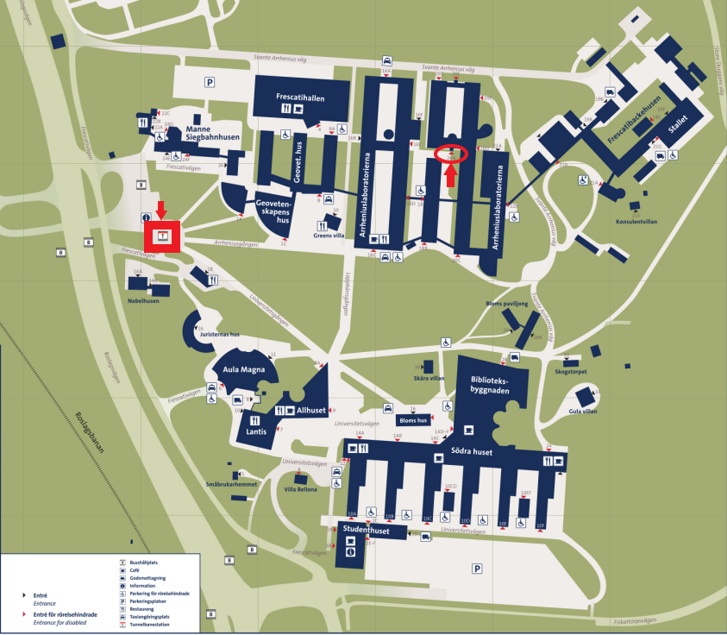

Welcome dinner venue: Restaurang Mårten Trotzig, Västerlånggatan 79, 111 29 Stockholm.

